**STAT 40001/STAT 59800 Statistical Computing Fall 2020**

**Lab-8**

1. All registered elevators in New York City are provided in the link below <https://www.kaggle.com/new-york-city/nyc-elevators/discussion/39528>

For your convenience the data are attached with this Lab-8 (NYC data)

1. Import the data in R.



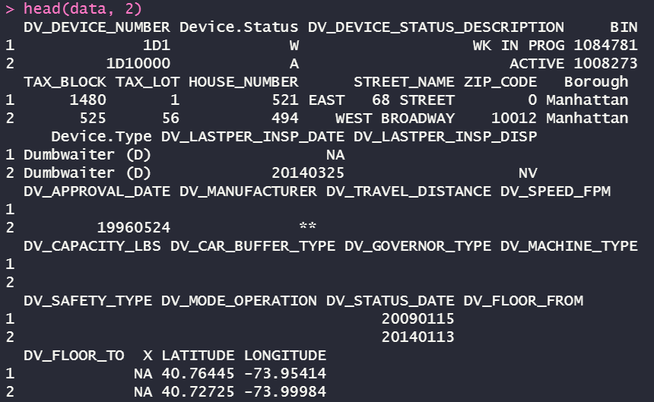

1. Not all elevators are active. How many are currently active?

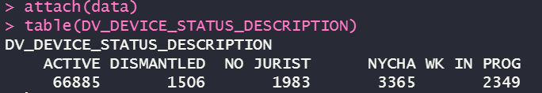

1. How many elevators are active in Manhattan borough?

*Extract a sub dataset with the Borough value of “Manhattan” from the original  
data set than we can use the table() to determine the number of “active” under   
this condition.*

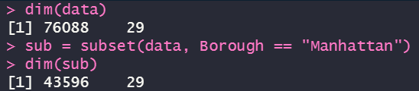

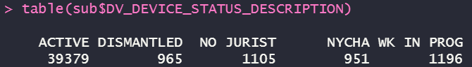

1. Generate 500 random numbers from a standard normal distribution and display them using a histogram.

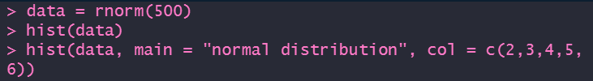

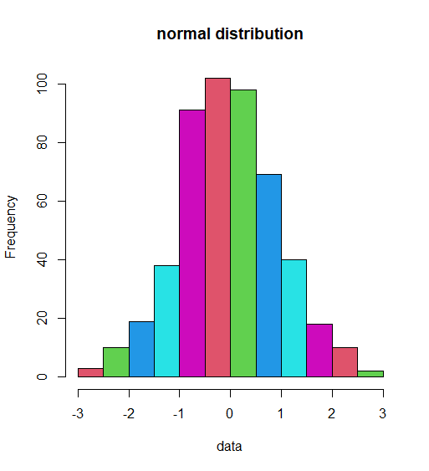

1. Plot pdf of a standard normal distribution by generating data in (-4, 4).



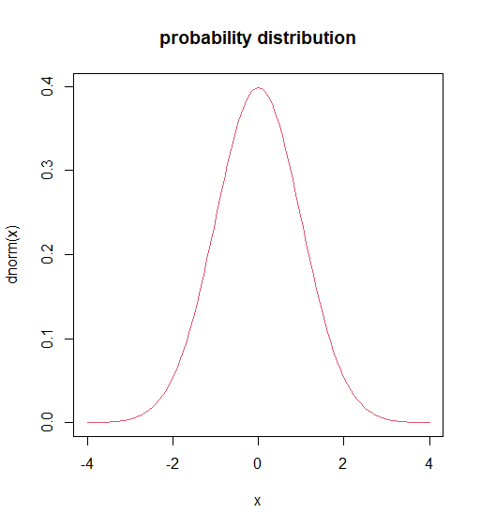

1. Generate 100 random numbers from a normal distribution with mean 5 and variance 64.

  


1. Generate 100 random sample form each of the following distribution and draw their normal qq plots
2. Normal

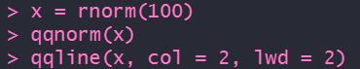

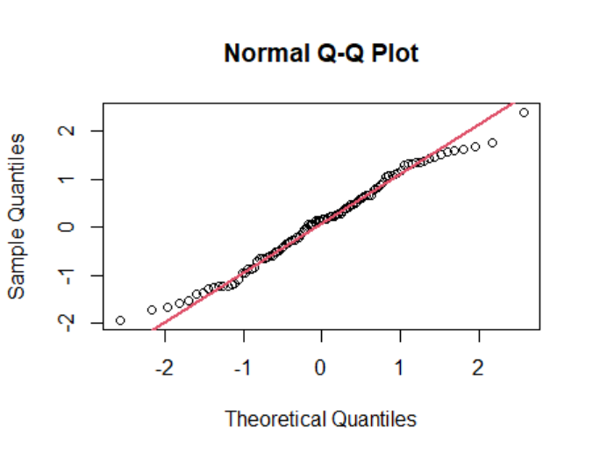

1. Student’s t (use degree of freedom 20)





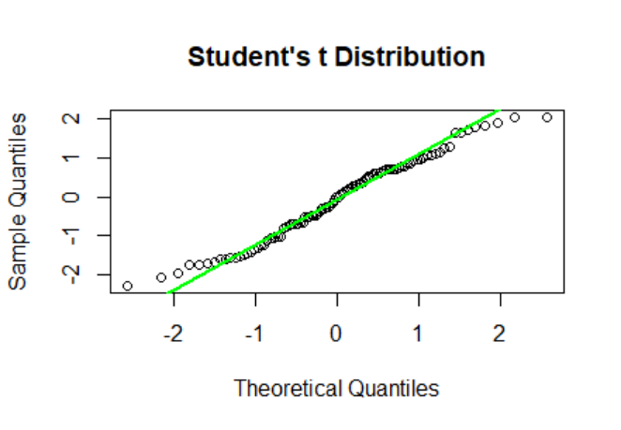

1. Exponential( Use rate=1)





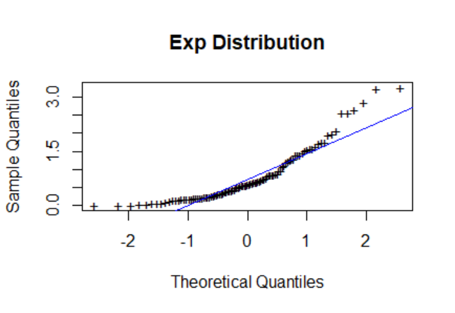

1. Uniform







